**PROJECT: chatbot to shop for Essentials During Pandemic Using Watson Assistant**

**1 INTRODUCTION**

* 1. **Overview**

A chatbot is a [software](https://en.wikipedia.org/wiki/Software_agent) application used to conduct an on-line chat [conversation](https://en.wikipedia.org/wiki/Conversation) via text or text-to-speech, in lieu of providing direct contact with a live human agent. Designed to convincingly simulate the way a human would behave as a conversational partner, chatbot systems typically require continuous tuning and testing. Chatbots are used in [dialog systems](https://en.wikipedia.org/wiki/Dialog_system) for various purposes including customer service, request routing, or for information gathering. While some chatbot applications use extensive word-classification processes, [natural language processors](https://en.wikipedia.org/wiki/Natural_language_processing), and sophisticated [AI](https://en.wikipedia.org/wiki/Artificial_intelligence), others simply scan for general keywords and generate responses using common phrases obtained from an associated library or [database](https://en.wikipedia.org/wiki/Database). Most chatbots are accessed on-line via website popups or through [virtual assistants](https://en.wikipedia.org/wiki/Virtual_assistant_(artificial_intelligence)). They can be classified into usage categories that include: [commerce](https://en.wikipedia.org/wiki/Conversational_commerce), [education](https://en.wikipedia.org/wiki/Education), [entertainment](https://en.wikipedia.org/wiki/Entertainment), [finance](https://en.wikipedia.org/wiki/Finance), [health](https://en.wikipedia.org/wiki/Health), [news](https://en.wikipedia.org/wiki/News), and [productivity](https://en.wikipedia.org/wiki/Productivity).

* 1. **Purpose**

Today, because of social distancing and other issues it can be risky for some people to shop for essential items in person. This project helps with this issue by giving people an online option to shop for essentials. With the help of Watson assistant, a chatbot is built.

1. **LITERATURE SURVEY**
   1. **Existing Problem**

A chatbot is a computer program designed to simulate a conversation with human users, especially over the Internet. Very often it happens that humans are not available to perform repetitive jobs and tasks such as in customer support and helping people in need with identical queries.

* 1. **Proposed Solution**

Chatbots address such needs, replacing human assets in large numbers. It is reliable and cost-effective as well. Among the most notable early chatbots are ELIZA (1966) and PARRY (1972). More recent notable programs include A.L.I.C.E., Jabberwacky and D.U.D.E (Agence Nationale de la Recherche and CNRS 2006). While ELIZA and PARRY were used exclusively to simulate typed conversation, many chatbots now include other functional features, such as games and web searching abilities. In 1984, a book called The Policeman's Beard is Half Constructed was published, allegedly written by the chatbot Racter (though the program as released would not have been capable of doing so).

1. **THEORETICAL ANALYSIS**
   1. **BLOCK DIAGRAM**

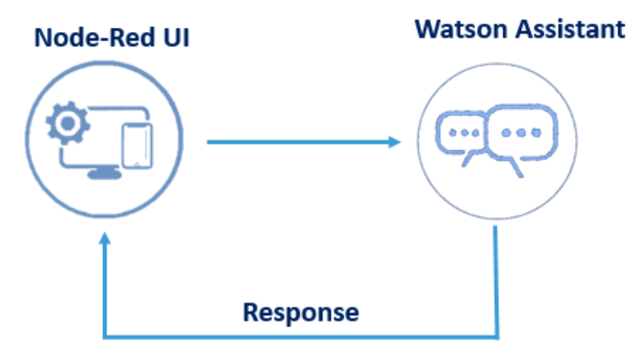

* 1. **HARDWARE AND SOFTWARE DESIGNING**

Node-Red UI is a web-based technology to interface the Watson Assistant to the web.

1. **RESULTS**

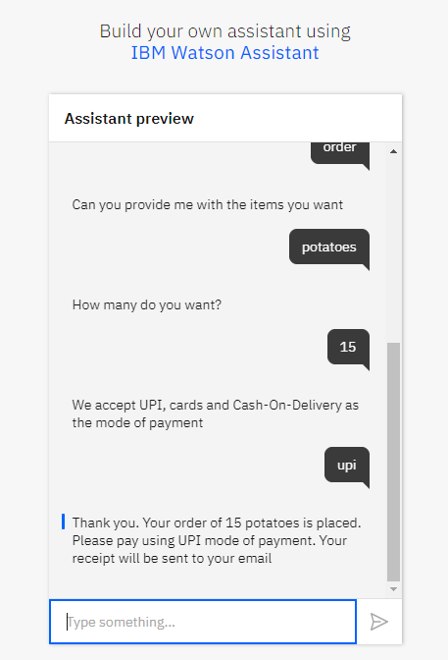

The Watson assistant is configured with the Node-Red and the Chatbot is deployed on the web.

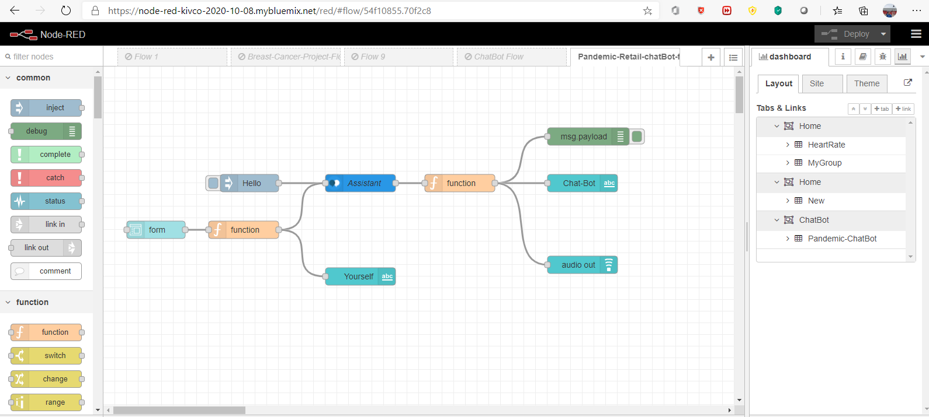

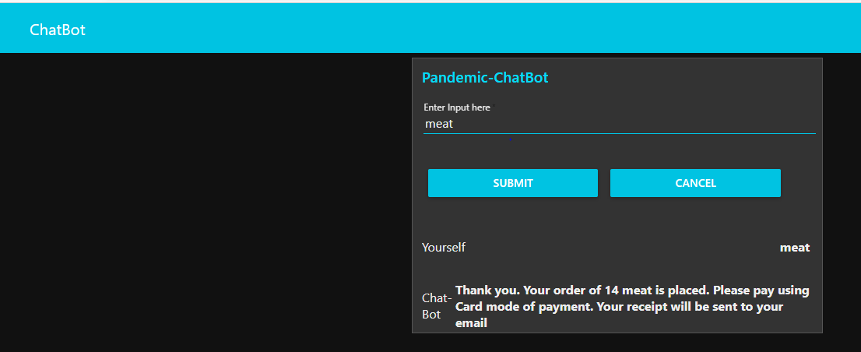

The Node-Red UI

1. **APPLICATIONS**

### 1- Customer Support

Your customer may be browsing in a fast manner but not completing any actions. Or her online behavior may not fit patterns you observe with other customers. These are good clues that the customer may need support which can be offered by your chatbot

### 2- Suggest products

Search results, personalized merchandising, recommendations can help your customer find specific products. However, when your customers online activity indicates a willingness to buy however customer is not buying, it may be a good time to probe what customer is exactly looking for. A conversational interface allows you to ask probing questions and understand your customers’ intent better.

### 3- Offer discounts

Your customer may be looking for a better price because she believes she qualifies for a discount. Understanding if she falls into one of your segments qualifying for a discount and offering that discount immediately can reduce friction in buying.

### 4- Prevent churn

Churn prediction is one of the most important use cases for subscription based industries. Understanding the reasons for churn and making churn reducing offers are a good fit for conversational interfaces

### Chatbots customized to serve specific industries

Some products are more prone to be converted into conversational interfaces while others aren’t. For example, text is not a good interface for displaying large amounts of data. However, if you offer these services, they can be completed in a conversational interface.